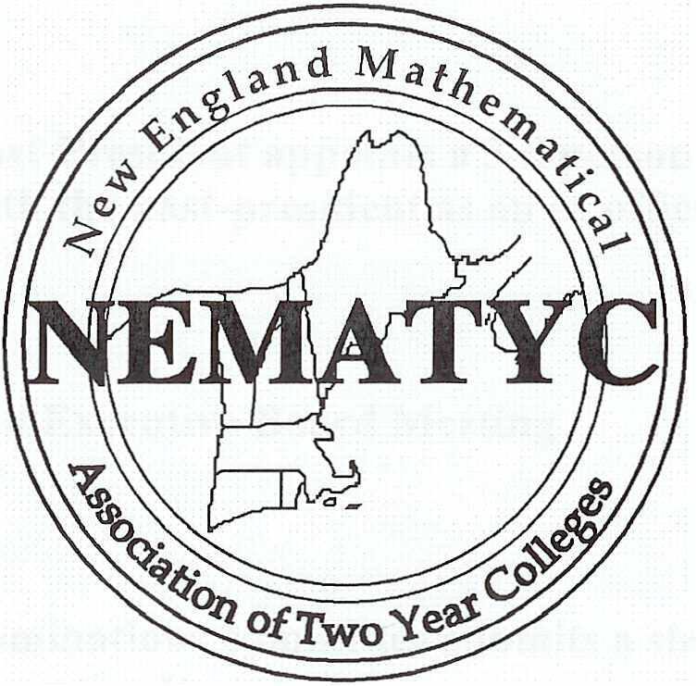

NEMATYC Executive Committee

Policy Manual

Revised June 7, 2016
NEMATYC GENERAL CALENDAR

May 1 - April 30 Yearly Membership and Budget year
Summer Summer Executive Committee Meeting
August 31 Articles for Fall newsletters
September 15* Past-President appoints a 3-5 person nominations committee with the past-president as an ex officio member
Sept/Oct. Fall Executive Committee Meeting
January 1 Nominations committee submits a slate of candidates to the Executive Committee
January 15 Articles for Spring newsletter due
January Winter Executive Committee Meeting
March/April Annual conference/Meeting of NEMATYC
August 31 Audit of Treasurer’s books completed

* Mandated by the Constitution
NEMATYC EXECUTIVE COMMITTEE MEETINGS
At all meetings:
a) Executive Committee members are expected to attend.
b) Secretary’s and treasurer’s reports shall be presented
c) AMATYC issues will be considered.

Standing Agenda Items
All meetings will follow Robert's Rules of Order and all agendas will contain typical agenda items such as approval of agenda, approval of previous meeting's minutes and reports in addition to the items listed below.
Summer Meeting
1. Discuss annual conference.
a) Review the report on the most recent conference.
b) Propose improvements.
c) Propose sites for future conferences (two years in advance).
d) Establish exhibitor’s fees for next conference.
2. Review the Executive Committee Policy Manual.
3. Discuss membership.
4. Create a list of open Executive Committee positions for the Nominations Committee.
5. Suggest members for the Nominations Committee.
6. Review Responsibilities for Fall Newsletter
7. The Minutes from the previous annual meeting will be presented for approval.

Fall Meeting
1. Choose site for future conference (two years in advance).
2. Discuss the upcoming conference.
3. Receive a list of the members of the Nominations Committee from the
Past-President.
4. Review the NEMATYC Constitution for potential changes.
Winter Meeting
1. Certify nominees for elected positions.
2. Review and consider new business for the annual meeting.
3. Discuss the upcoming conference.
4. Determine how the AMATYC Affiliate Scholarship will be awarded that year.
Annual Meeting
1. Conduct the election for open Executive Committee positions.
2. Present any new business.
3. Acknowledge AMATYC Officers.

OFFICERS of the ASSOCIATION
President
- Establish the dates and locations of the summer, fall, and winter Executive Committee meetings in consultation with the board. If possible, each succeeding meeting date should be determined at the previous meeting.
- Ensure that all members of the Executive Committee are supplied with updated, current copies of the Executive Committee Policy Manual, Executive Committee Directory, and NEMATYC Constitution.
- Select NEMATYC delegates to the annual AMATYC meeting.
- Conduct the Executive Committee and Annual Business meetings.

VICE PRESIDENT
- Conduct meetings and fulfill the obligations of the President in situations where the President is absent.
- If the President is unable to continue in office the Vice-President will assume the office of President.
- Coordinate the Fall Dinner Meeting.
SECRETARY
Minutes of all Executive Committee Meetings should be mailed or emailed to Committee members within one month of each meeting.
May Report to all candidates for office of NEMATYC the results of the election.

June Send a list of the Executive Committee members to: AMATYC, the
AMATYC northeast regional vice president, the NEMATYC webmaster, and any other relevant organizations.
Send Thank You notes to institutions/individuals who contributed to the annual conference. A list will be compiled by the Executive Committee.
Ongoing Provide supplies of official NEMATYC stationery as requested.
Ongoing Handle all NEMATYC correspondence.
Ongoing Maintain an up-to-date copy of the Constitution

Past-President
- Appoint the Nominations Committee by September 15th every year.
- Supervise the maintenance of the Policy Manual.

Treasurer
- Give a financial report at each Executive Committee meeting.
- Give an annual Treasurer’s Report at the business meeting during the Annual Conference.
- Maintain and keep accurate records of the NEMATYC bank accounts.
- Write checks as needed.
- Receive membership fees from potential members who do not attend the Annual Conference and send their contact information to the Membership Coordinator and the Newsletter Production Editor.
- File or arrange for filing of any tax forms.

APPOINTED POSITIONS
The Newsletter Editor will:
- Create and distribute a Newsletter in the Fall to include a call for papers at the next conference.
- Create and distribute a Newsletter in the Spring to include the conference announcement, a tentative program, registration form, and the recommended slate of candidates.
- Create and distribute announcements at other times as determined by the Executive Committee.
- Serve on the Executive Committee as a non-voting member.
- Create schedule of newsletter submission activities for the coming year.
- Serve a three year term.

The Membership Coordinator will:
- Solicit and recruit new members
- Maintain a current membership list and co-ordinate with Treasurer.
- Coordinate with the Treasurer to determine up-to-date dues payments.
- Encourage membership participation in organization conferences and programs
- Maintain a system of campus representatives to facilitate timely electronic and written communication with colleges in the service area.
- Encourage retention of membership through newsletter, mail, electronic, and personal contact with former members.
- Perform other related duties.
- Serve on the Executive Committee as a non-voting member.
- Serve a three year term.

The Conference Chairperson will:
- Recommend the date(s) for the next Annual Conference to the Executive Committee.
- Organize and host the next Annual Conference.
- Serve on the Executive Committee as a non-voting member.
- Serve until the end of the conference for which this appointee is the chairperson and then assume the role of Immediate Past-Conference Chairperson (see duties of Immediate Past-Conference Chairperson below.)
The Conference Exhibitor Chairperson will:
- Contact vendors/exhibitors regarding their presence at the annual meeting.

- Arrange with the conference chair for appropriate space for vendors/exhibitors at the conference.

- Arrange with the conference chair for presentation rooms for vendors/exhibitors as appropriate.
4. Ensure collection of appropriate exhibitor fees.
5. Forward accounting of exhibitor fees to Conference Chair for the financial accounting of the conference.
6. Serve on the Executive Committee as a non-voting member.

The Immediate Past- Conference Chairperson will:
- Serve as advisor to the Conference Chairperson and Executive Committee.
- Submit a written report about the conference and a financial accounting of the conference at the next Executive Committee meeting or to the president within 60 days of the conference. This report should include recommended changes for future conferences.
A template for the accounting is available at www.NEMATYC.org at the end of the on-line NEMATYC Conference Chair Information.
- Serve on the Executive Committee as a non-voting member.
- Serve from the end of the conference for which this appointee is the chairperson to the end of the following conference.
- Review the Conference Policy Manual and suggest changes.

The Webmaster will:
- Maintain the NEMATYC website.
- Consult with the members of the Executive Committee.
- Serve on the Executive Committee as a non-voting member.
- Serve a three year term.

The Facebook Editor will:
- Maintain the NEMATYC Facebook page

- Solicit news and pictures to display on the site

- Periodically post appropriate content

- Encourage NEMATYC members and others to “lile” the page

NEMATYC STUDENT MATH LEAGUE RECOGNITION AWARD PROGRAM
The purpose of the NEMATYC Student Math League Recognition Award Program is to foster extracurricular mathematics learning opportunities for students through participation in the AMATYC Student Math League.

NEMATYC will recognize students who participate in the AMATYC Student Mathematics League Competition by distributing awards (annually) to the top scoring student at each participating school in NEMATYC’s service area, Maine, Massachusetts, New Hampshire, Rhode Island, Vermont. Each student will receive a $100 Recognition Award.
The Student Math League Awards Coordinator will:
- Write an article for each newsletter
- Determine the student award winners.
- Distribute awards and checks to the appropriate people.
- Announce winners at the Business Meeting of the Spring Conference.
- Serve on the Executive Committee as a non-voting member
- Serve a 3 year term
- Co-ordinate Lois Martin Team Award presentation
- Funds from uncashed SML checks to be returned to the checking account after one year.
Note: The treasurer will write the checks.
Policy on
Membership, Honoraria, Stipends & Reimbursements
Membership
Membership must be renewed on a yearly basis.
Membership can be obtained by paying the membership fee along with the conference fee or by paying the membership fee directly to the Treasurer.
Membership lasts for a year or until the next annual conference, whichever is longer.
Annual Conference
Keynote Speaker(s): maximum total honoraria of $300. Cost of conference meals and the registration fee will be waived.
Presenters: Registration fee will be waived for one presenter per session.
Extraordinary expenses need Committee approval.
Refund Policy
A refund of 100% of your advanced registration fees less the dues amount will be given upon receipt of a written request postmarked no later than two weeks prior to the conference. A 50% refund less the dues amount will be given if written request is postmarked within the two weeks prior to the conference.

A refund for the Friday night dinner will be given dependent upon restaurant policy.

No refunds for non-attendance will be given for requests postmarked after the date of the conference.

All requests should be sent to the NEMATYC Conference Chairperson

Refunds will be processed approximately four to six weeks after the conference.

Current Project ACCCESS fellows will have registration and membership fees for the Annual Conference waived.

Fall Dinner Meeting
Current Project ACCCESS Fellows will have registration and
membership fees for the Fall Dinner Meeting waived.

Keynote speaker(s): Pay a maximum $200 honorarium, waive dinner
fee, and waive a year’s NEMATYC Membership dues for the speaker.

AMATYC
NEMATYC will pay a subsidy of up to $500 for the President or a designee to attend the annual AMATYC Conference.

Created January, 2001
Revised November, 2005
Revised June, 2009
Revised May, 2010
Revised January, 2011
Revised May, 2015

